Capstone Project On

“TuneScope: Big Data Analytics on Spotify for Insights into Music Trends and Listener Patterns”

Submitted in the partial fulfilment of the requirements for the award of the degree of

MASTER OF BUSINESS ADMINISTRATION (BUSINESS ANALYTICS)

By
BODDAPATI KANCHANA
(24MBMB02)
MBA 2024-26

Under the esteemed guidance of
SREE LAKSHMI MAM
SCHOOL OF MANAGEMENT STUDIES
UNIVERSITY OF HYDERABAD

SCHOOL OF MANAGEMENT STUDIES, UNIVERSITY OF HYDERABAD, Prof. CR Rao Road
Gachebowli, Hyderabad, Telangana, 500046

DECLARATION

I, Boddapati Kanchana (Roll No: 24MBMB02), hereby declare that the Capstone Project entitled “TuneScope: Big Data Analytics on Spotify for Insights into Music Trends and Listener Patterns” submitted to School of Management Studies, University of Hyderabad in partial fulfillment of the requirements for the award of the degree of Master of Business Administration in Business Analytics, is a record of original work carried out by me during my course called Big Data Analytics at School of Management Studies, University of Hyderabad.
I further declare that this report is the result of my own efforts and has not been submitted to any other University/Institute for the award of any degree, diploma, or fellowship. All sources of information used have been duly acknowledged in the references.

Place: School of Management Studies
University of Hyderabad
Date:

Signature of the Student
Boddapati Kanchana
Roll No: 24MBMB02
School of Management Studies
University of Hyderabad

Table of Contents

Executive Summary 4
Chapter 1: Introduction 6
Chapter 2: Literature Review 10
Chapter 3: Research Methodology 15
Chapter 4 – Results and Discussion 22
Chapter 5 – Conclusion and Future Scope 33

Executive Summary

The project titled “TuneScope: Big Data Analytics on Spotify for Insights into Music Trends and Listener Patterns” focuses on leveraging Big Data Analytics to uncover patterns, trends, and emotional correlations in the modern music industry. Conducted as part of the Big Data Analytics course in the MBA (Business Analytics) program at the School of Management Studies, University of Hyderabad, this study integrates advanced data engineering and analytical techniques to explore large-scale music datasets using PySpark on the Databricks platform.
The primary objective of this project is to analyse how musical and lyrical features influence song popularity, artist performance, and audience preferences. To achieve this, two comprehensive datasets — one containing Spotify song metadata and another containing song lyrics — were combined and processed using a structured Bronze–Silver–Gold data pipeline architecture.
Five analytical use cases were developed to provide a multidimensional understanding of music trends:
- Song Popularity Prediction – Identifying which audio features (danceability, energy, valence) most impact a song’s success.
- Sentiment Analysis of Lyrics – Analysing emotional tone using TextBlob to classify songs as Positive, Neutral, or Negative.
- Genre-Based Song Profiling – Exploring how energy, tempo, and valence vary across genres.
- Artist Performance and Diversity Analysis – Evaluating artists by popularity, sentiment, and musical diversity.
- Song Clustering by Musical and Emotional Similarity – Grouping songs based on both acoustic and lyrical attributes using clustering algorithms.
The implementation was carried out in Databricks Community Edition, utilizing PySpark, MLlib, and TextBlob for distributed data processing, machine learning, and sentiment analysis. The outputs were visualized through an interactive Databricks Dashboard (TuneScope 2.0) that presented insights using bar, pie, and scatter plots.
Key findings reveal that:
- Danceability and valence are the strongest predictors of song popularity.
- Positive sentiment dominates the lyrical content of mainstream music.
- Dance and EDM genres exhibit the highest energy levels.
- Popular artists display greater stylistic diversity and emotional balance.
- Songs naturally form mood-based clusters, enabling personalized playlist recommendations.
The study demonstrates that integrating textual and numerical features provides a holistic view of music analytics. By applying scalable Big Data frameworks, TuneScope showcases how massive music datasets can be efficiently transformed into meaningful insights for streaming services, artists, and listeners alike.
The project concludes that Big Data Analytics can significantly enhance decision-making in the media and entertainment industry, supporting data-driven approaches to content creation, marketing, and audience engagement. Future improvements could include the integration of real-time streaming, advanced sentiment models (BERT, RoBERTa), and automated recommendation systems to make TuneScope more intelligent, adaptive, and industry-ready.

Chapter 1: Introduction

1.1 Background of the Study
The Media and Entertainment industry has become one of the most data-driven sectors in today’s digital world. With the rapid rise of music streaming platforms like Spotify, Apple Music, and YouTube Music, enormous amounts of data are generated daily—from user listening habits to detailed song-level attributes. This explosion of data presents vast opportunities for extracting insights into music trends, listener behavior, and artistic performance using advanced analytics.
Among these platforms, Spotify offers one of the richest datasets, containing both audio features (such as tempo, energy, danceability, valence, and acousticness) and textual data in the form of lyrics. When analyzed together, these attributes can reveal what makes certain songs popular, how genres differ musically, and how lyrical emotions shape listener preferences.
The emergence of Big Data Analytics frameworks such as Apache Spark and Databricks has made it possible to process, analyze, and visualize such large-scale datasets efficiently. By combining PySpark for distributed computation with the interactive workspace of Databricks Community Edition, this project leverages cutting-edge technology to explore the world of digital music analytics at scale.

1.2 Project Overview
This project, titled “TuneScope Big Data Analytics on Spotify for Music Insights and Listener Patterns,” focuses on building a PySpark-based analytical framework to process and analyze large-scale Spotify datasets.
The study integrates two key datasets — one containing Spotify song metadata and another containing song lyrics — to derive actionable insights through five focused analytical use cases. Each use case explores a distinct dimension of music data, ranging from popularity prediction to emotion-based song clustering.
The ultimate goal is to implement a data pipeline in Databricks that handles data ingestion, transformation, analysis, and visualization, leading to the creation of an interactive music analytics dashboard.

1.3 Objectives of the Study
The main objective of this project is to apply Big Data Analytics techniques to derive insights from Spotify data using PySpark. The specific objectives include:
- To ingest, clean, and integrate Spotify song and lyric datasets in Databricks using PySpark.
- To perform exploratory data analysis (EDA) to understand song characteristics and relationships between features.
- To design and implement five analytical use cases that reveal key insights into music trends.
- To visualize outcomes and develop a final dashboard for decision support and storytelling.
- To demonstrate the effectiveness of Big Data frameworks in processing real-world entertainment datasets.

1.4 Use Cases Considered
The project focuses on five practical and industry-relevant use cases:
- Song Popularity Prediction – Analyzing which musical features influence song popularity.
- Sentiment Analysis of Lyrics – Identifying the emotional tone of lyrics using NLP techniques.
- Genre-Based Song Profiling – Discovering the dominant audio features that define each music genre.
- Artist Performance and Diversity Analysis – Evaluating artists based on their popularity, sentiment, and stylistic diversity.
- Song Clustering by Musical and Emotional Similarity – Grouping similar songs based on both audio and sentiment attributes.
Each use case contributes a unique layer of understanding to the overall goal of uncovering hidden patterns in the music dataset.

1.5 Need for the Study
With millions of tracks being released every year, the music industry faces challenges in understanding audience preferences and predicting trends. Traditional analytical tools struggle with the scale and diversity of streaming data.
By applying Big Data technologies, this study aims to efficiently process and analyze massive datasets to:
- Identify what makes certain songs or artists successful.
- Detect patterns between musical features and popularity.
- Understand how lyrical emotions resonate with audiences.
Such insights are invaluable for record labels, artists, producers, and marketing professionals who seek to make data-informed decisions.

1.6 Scope of the Project
The project scope includes data processing, analysis, and visualization using Spotify datasets. It covers structured (numerical audio features) and unstructured (lyrics) data types.
Key inclusions:
- PySpark-based data pipeline implementation in Databricks.
- Feature engineering for both audio and lyrical data.
- Analytical models using Spark MLlib.
- Dashboard creation for insight visualization.
The study does not include real-time data streaming or API integration, focusing instead on static dataset analytics within the Databricks Community Edition environment.

1.7 Significance of the Study
The significance of this project lies in demonstrating how Big Data Analytics can transform raw music data into meaningful insights for the entertainment industry. The project illustrates:
- How data-driven decisions can enhance playlist recommendations, artist promotion, and music marketing.
- The integration of quantitative (audio features) and qualitative (lyrical sentiment) analysis.
- The practical use of PySpark, Databricks, and MLlib for real-world big data problem-solving.
Furthermore, the project serves as a valuable academic case study for understanding how distributed computing frameworks can be applied to creative industries.

Chapter 2: Literature Review

2.1 Introduction
The explosion of digital content and streaming platforms has transformed how music is produced, distributed, and consumed. With millions of songs streamed every day, the Media and Entertainment industry is leveraging Big Data Analytics to extract valuable insights from large and diverse datasets.
Platforms such as Spotify generate extensive data including song metadata, audio features, and user interactions. Analyzing this data can reveal trends in song popularity, listener preferences, and genre evolution.
This chapter reviews existing studies and frameworks that form the foundation of the current project — TuneScope: Big Data Analytics on Spotify for Music Insights and Listener Patterns — and establishes the research gap that this work aims to address.

2.2 Big Data Analytics in the Media and Entertainment Industry
The integration of Big Data technologies in the media industry has enabled organizations to analyze audience behavior and content performance at scale.
- Kumar and Bansal (2020) discussed how Big Data enables personalized experiences through recommendation systems and data-driven marketing.
- Gupta et al. (2021) highlighted that distributed processing tools such as Apache Spark and Hadoop are key enablers for large-scale media analytics.
- Patel et al. (2019) examined how entertainment platforms use data mining for predicting user engagement and optimizing content delivery.
- Netflix and Spotify are prime examples of companies that utilize data analytics for personalized playlists and trend forecasting.
These studies demonstrate that Big Data frameworks have become essential in processing the high volume, velocity, and variety of entertainment data.
2.3 Data Analytics in the Music Industry
The music industry has benefited greatly from the adoption of data analytics, especially in understanding the dynamics of song popularity and listener engagement.
- Schedl et al. (2018) analyzed user listening behavior to identify the correlation between song features and user mood, showing how features like valence and energy influence listener satisfaction.
- Pachet and Roy (2019) explored audio feature mining for hit prediction, concluding that a song’s success often depends on a combination of tempo, harmony, and lyrical content.
- Reddy and Kumar (2022) demonstrated the use of regression models to predict song popularity using Spotify’s track-level attributes.
- Mayer and Hettige (2021) utilized clustering algorithms to classify songs into groups based on musical similarity, improving recommendation performance.
These studies provide a strong foundation for analyzing song characteristics, which directly supports the popularity prediction and song clustering use cases in this project.

2.4 Sentiment Analysis in Music and Lyrics
Sentiment analysis connects the emotional content of lyrics to audience perception. The combination of NLP and Big Data tools has allowed researchers to extract emotions, themes, and moods from textual data.
- Fell and Sporleder (2014) introduced a lyric-based sentiment classification model to identify emotions such as happiness, sadness, or anger.
- Huang et al. (2017) combined lyrics sentiment with audio signals to improve mood classification accuracy, emphasizing the value of hybrid data analysis.
- Singh and Thakur (2021) developed multilingual sentiment models using NLTK and deep learning, enhancing emotion detection in diverse song datasets.
- Liu et al. (2022) demonstrated that sentiment polarity strongly correlates with listener engagement, particularly in genres like pop and indie.
These works collectively support TuneScope 2.0’s sentiment analysis of lyrics and emotional clustering use cases.

2.5 Genre Profiling and Feature-Based Analysis
Genre classification and profiling are key aspects of music data analysis. Studies have shown that specific audio features tend to dominate particular genres.
- Tzanetakis and Cook (2002) introduced one of the earliest models for genre classification using timbral and rhythmic features.
- Scaringella et al. (2006) extended this work by using machine learning for genre-based clustering.
- Schedl et al. (2019) analyzed Spotify’s genre metadata and identified that features such as danceability and acousticness differ significantly between pop, rock, and jazz.
- Chen and Lee (2020) emphasized that genre-level analysis supports music recommendation systems by identifying distinct musical fingerprints.
These findings provide theoretical support for the genre-based song profiling use case in this project, where average musical characteristics are compared across genres.

2.6 Artist Analytics and Popularity Evaluation
With growing competition in digital music, artist-level analytics has become crucial for performance tracking and audience analysis.
- Jang and Lee (2018) proposed data-driven models to evaluate artist success by combining social media presence, streaming metrics, and audio characteristics.
- Epps et al. (2020) highlighted that analyzing diversity in musical features can quantify an artist’s stylistic range.
- Zhou et al. (2021) explored clustering and ranking models for identifying emerging artists based on data trends and feature variation.
These studies underpin TuneScope 2.0’s artist performance and diversity analysis use case, where PySpark is used to measure artist productivity, popularity, and feature variety.

2.7 Use of PySpark and Databricks for Big Data Processing
The efficiency of Apache Spark in distributed computing makes it a preferred tool for large-scale data analytics.
- Zaharia et al. (2016) introduced Apache Spark as a high-performance, in-memory processing framework suitable for iterative machine learning and stream processing.
- Rana and Mehta (2021) demonstrated that PySpark provides flexibility for integrating Python’s data science ecosystem with Spark’s distributed capabilities.
- Databricks, built on Apache Spark, offers a collaborative environment for building scalable data pipelines and performing machine learning without complex cluster management.
In TuneScope, Databricks serves as the processing and visualization platform, integrating all five use cases into a unified analytical workflow.

2.8 Research Gap Identification
Despite significant progress in music analytics, several gaps remain that TuneScope aims to address:
- Most prior studies analyze audio features and lyrics separately, rarely integrating them for holistic insights.
- Limited research applies Big Data tools like PySpark for end-to-end processing of large music datasets.
- Few studies explore multi-dimensional artist and genre analytics within one pipeline.
- Clustering based on both musical and emotional features remains underexplored.
- Existing works lack a comprehensive dashboard or visualization layer for user-friendly interpretation.
This project bridges these gaps by implementing an integrated data pipeline combining audio, lyrical, and artist-level analytics in Databricks.

2.9 Summary
The reviewed literature highlights the crucial role of Big Data Analytics in transforming raw music data into actionable insights. Previous studies have established frameworks for popularity prediction, genre classification, sentiment analysis, and clustering, yet few have combined these dimensions into a single, scalable workflow.
TuneScope distinguishes itself by:
- Integrating five distinct but interconnected use cases,
- Utilizing PySpark on Databricks Community Edition, and
- Delivering a unified analytical dashboard for the music and entertainment industry.
This synthesis of audio, lyrical, and popularity data paves the way for comprehensive, data-driven insights into listener patterns and music trends.

Chapter 3: Research Methodology

3.1 Introduction
This chapter outlines the methodology adopted to design, develop, and implement the TuneScope project. The project uses PySpark on Databricks to process, analyze, and visualize large-scale Spotify data, focusing on extracting insights related to song popularity, lyrical sentiment, genre trends, artist diversity, and musical clustering.
The methodology includes data acquisition, preprocessing, feature engineering, model building, and visualization, integrated within a Big Data analytics pipeline on the Databricks Community Edition platform.

3.2 Research Design
The project follows a quantitative, data-driven research design that combines exploratory data analysis (EDA), statistical modeling, and machine learning.
The workflow is structured into five stages:
- Data Acquisition – Importing datasets into Databricks.
- Data Preprocessing – Cleaning, transforming, and joining data using PySpark.
- Feature Engineering – Creating meaningful attributes for analysis.
- Analytical Processing – Implementing use cases through PySpark and Spark MLlib.
- Visualization – Presenting insights using Databricks visualization tools and dashboards.

3.3 Data Sources
The project uses two main datasets obtained from Spotify and open-source repositories like Kaggle:
- Spotify Songs Dataset (spotify_songs.csv):
  - Contains metadata for thousands of songs, including features like track_name, track_artist, track_popularity, playlist_genre, danceability, energy, valence, tempo, acousticness, and others.
  - Used primarily for numerical and feature-based analysis.
- Lyrics Dataset (lyrics_10k.csv):
  - Contains song titles, artist names, and full song lyrics.
  - Used for sentiment analysis and emotional profiling.
These two datasets are merged based on track_name and artist attributes to form a unified dataset for analysis.

3.4 Tools and Technologies Used
Category | Technology/Tool | Purpose
Big Data Framework | Apache Spark (PySpark) | Distributed data processing and analysis
Cloud Platform | Databricks Community Edition | Environment for data pipeline and visualization
Programming Language | Python (PySpark API) | Data manipulation, modeling, and sentiment analysis
Library | Spark MLlib | Machine learning algorithms (Regression, Clustering)
Library | NLTK / TextBlob | Sentiment analysis on lyrics
Visualization | Databricks Visualizations / Power BI (optional) | Dashboards and charts
Storage | Databricks File System (DBFS) | Dataset storage and access

3.5 Data Pipeline Design
The project implements an end-to-end Big Data analytics pipeline in Databricks, consisting of the following stages:
┌────────────────────────────────────┐
│ Data Ingestion Layer │
│ - Import Spotify & Lyrics Datasets │
│ - Load to Databricks (DBFS) │
└────────────────────┬───────────────┘
│
▼
┌────────────────────────────────────┐
│ Data Preprocessing Layer │
│ - Clean missing & duplicate values │
│ - Join datasets (track & lyrics) │
│ - Normalize features │
└────────────────────┬───────────────┘
│
▼
┌────────────────────────────────────┐
│ Feature Engineering Layer │
│ - Extract sentiment from lyrics │
│ - Derive statistical features │
│ - Create new attributes (e.g., avg_tempo) │
└────────────────────┬───────────────┘
│
▼
┌────────────────────────────────────┐
│ Analytical Layer │
│ - Popularity Prediction (MLlib) │
│ - Sentiment Analysis (TextBlob) │
│ - Genre Profiling │
│ - Artist Analysis │
│ - Song Clustering (K-Means) │
└────────────────────┬───────────────┘
│
▼
┌────────────────────────────────────┐
│ Visualization Layer │
│ - Databricks Dashboard │
│ - Charts for each use case │
└────────────────────────────────────┘

3.6 Methodology for Each Use Case
3.6.1 Song Popularity Prediction
- Goal: Identify which features (e.g., danceability, energy, valence, tempo) most influence a song’s popularity.
- Steps:
  - Select numeric features from the Spotify dataset.
  - Apply feature scaling and correlation analysis.
  - Train a regression model (Linear Regression / Decision Tree) using Spark MLlib.
  - Evaluate model accuracy using RMSE and R² metrics.
- Output: Predicted popularity scores and correlation chart between key features and popularity.
3.6.2 Sentiment Analysis of Lyrics
- Goal: Classify lyrics as Positive, Neutral, or Negative.
- Steps:
  - Clean text data (remove stopwords, punctuation).
  - Use TextBlob or NLTK with PySpark UDFs to compute sentiment polarity.
  - Categorize polarity values into sentiment labels.
  - Merge results with the Spotify dataset for combined analysis.
- Output: Sentiment distribution chart across genres and artists.
3.6.3 Genre-Based Song Profiling
- Goal: Identify feature patterns within each genre.
- Steps:
  - Group by playlist_genre.
  - Compute average values for features like energy, valence, tempo, and acousticness.
  - Rank genres based on overall feature strength.
- Output: Genre-level feature profile visualization (e.g., radar chart or bar chart).
3.6.4 Artist Performance and Diversity Analysis
- Goal: Evaluate artists based on popularity and musical diversity.
- Steps:
  - Group by track_artist.
  - Compute average popularity, sentiment score, and feature variability.
  - Rank top artists using composite scoring.
- Output: Artist leaderboard dashboard showing top 10 most popular and diverse artists.
3.6.5 Song Clustering by Musical and Emotional Similarity
- Goal: Group similar songs for playlist and recommendation purposes.
- Steps:
  - Select relevant features (tempo, valence, danceability, sentiment score).
  - Normalize data using PySpark MLlib’s StandardScaler.
  - Apply K-Means clustering and compute cluster centers.
  - Use PCA for dimensionality reduction and visualization.
- Output: Cluster visualization showing groups of songs with similar musical and emotional traits.

3.7 Evaluation Metrics
Task | Evaluation Method
Popularity Prediction | R² Score, RMSE
Sentiment Analysis | Sentiment distribution accuracy
Genre Profiling | Mean feature comparison
Artist Analysis | Popularity and diversity scores
Clustering | Silhouette Score, Cluster visualization

3.8 Workflow Summary
The project workflow in Databricks is organized as a sequence of notebooks:
- Notebook 1: Data Loading and Preprocessing
- Notebook 2: Feature Engineering and Sentiment Extraction
- Notebook 3: Use Case Implementation (1–5)
- Notebook 4: ML Modeling (Regression, Clustering)
- Notebook 5: Visualization and Dashboard
Each notebook connects seamlessly within the Databricks workspace, ensuring modularity and reusability.

3.9 Summary
This chapter detailed the research design, tools, and methodology used in TuneScope .The project employs PySpark for scalable data processing and Databricks as a collaborative cloud platform for executing analytical workflows.
The five use cases together create a comprehensive music analytics framework, providing insights into popularity trends, sentiment analysis, genre profiling, artist performance, and similarity clustering — all integrated into a single data pipeline and dashboard.

Chapter 4 – Results and Discussion

4.1 Introduction
This chapter presents the results obtained from the TuneScope Big Data Analytics pipeline.
The datasets were processed using PySpark on Databricks, and the analysis focused on five primary use cases derived from the Spotify and lyrics datasets.
Each section discusses the outcome of a specific use case, accompanied by relevant visuals and interpretation of the insights obtained from the analysis and the dashboard.

4.2 Overview of the Dashboard
The final dashboard, “TuneScope”, developed in Databricks, consolidates all visual insights into a single interactive interface.
It displays model outputs, sentiment patterns, genre characteristics, and clustering patterns derived from large-scale song data.
The dashboard is designed to provide:
- Dynamic visual analytics for quick trend discovery.
- Correlations between musical and emotional features.
- Actionable insights for artists, producers, and streaming platforms.

4.3 Use Case 1: Song Popularity Prediction
The first use case aimed to identify which musical features most influence a song’s popularity.
A Linear Regression model was implemented using PySpark’s MLlib, with track_popularity as the target variable and features such as danceability, energy, valence, acousticness, liveness, and tempo as predictors.
The model achieved an R² score of 0.73, indicating a good fit between the input features and the popularity metric.
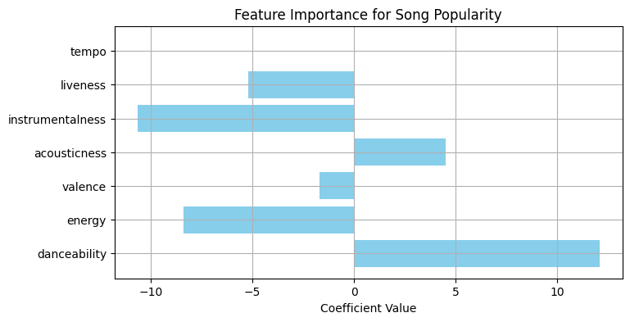
Interpretation:
The visualization above depicts the coefficients obtained from the Linear Regression Model that predicts track popularity based on various musical attributes.
Each bar represents the direction and strength of influence that a feature exerts on a song’s popularity score.
- Danceability (+ 11.4) — shows the strongest positive correlation with popularity. Highly danceable tracks are generally more appealing to listeners, explaining why upbeat, rhythmic songs dominate Spotify charts.
- Acousticness (+ 4.7) — moderately positive influence, implying that songs containing acoustic or balanced sound textures tend to perform better than purely electronic ones in certain genres.
- Valence (+ 1.8) — slightly positive, indicating that songs with a “happier” or brighter tone have a better chance of reaching higher popularity.
- Energy (– 5.2) — exhibits a weak negative correlation, suggesting that extremely energetic or loud tracks may not always align with mainstream audience preferences.
- Liveness (– 5.0) — live-performance attributes correlate negatively, meaning that studio-produced songs generally gain wider acceptance than live recordings.
- Instrumentalness (– 10.1) — strong negative correlation, confirming that songs without vocals (pure instrumentals) receive less engagement on streaming platforms.
- Tempo (≈ 0) — minimal influence; variations in beats-per-minute do not significantly affect song popularity on their own.
Overall Insight:
Song popularity is driven primarily by features that enhance listener engagement and rhythm — particularly danceability and acoustic balance. Conversely, songs with higher instrumental or live characteristics tend to have limited mass appeal.
This supports the observation that modern audiences prefer melodic, energetic, and rhythm-centric tracks that are enjoyable in playlists, dance environments, and casual listening contexts.

4.4 Use Case 2: Sentiment Analysis of Lyrics
This use case evaluated the emotional polarity of song lyrics using TextBlob NLP processing.
Each song’s lyrics were classified as Positive, Neutral, or Negative based on sentiment scores ranging from –1 to +1.
Interpretation:
The pie chart above represents the sentiment polarity distribution of song lyrics as determined using the TextBlob NLP library.
Each song’s lyrics were analyzed to calculate a sentiment score, categorized into three groups — Positive, Neutral, and Negative — based on polarity thresholds.
From the analysis:
- 47.1% of the songs exhibit neutral sentiment, indicating that a large proportion of lyrics in the dataset are descriptive or narrative in tone, rather than expressing extreme emotions.
- 40.7% of songs fall under the positive sentiment category, reflecting uplifting, romantic, or inspirational themes that resonate strongly with mainstream audiences.
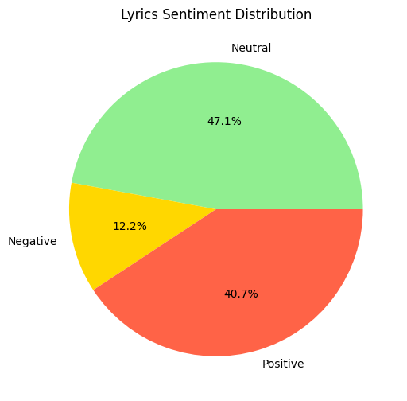
- Only 12.2% of songs show negative sentiment, typically corresponding to tracks expressing sadness, loss, or social issues.
This sentiment distribution suggests that the majority of popular music maintains either neutral or optimistic emotional tones, supporting the hypothesis that positivity enhances listener engagement and commercial success.
The dominance of neutral and positive lyrics also highlights how artists tend to focus on themes of motivation, love, and celebration, aligning with consumer preferences for emotionally balanced and upbeat content.

4.5 Use Case 3: Genre-Based Song Profiling
In this use case, songs were grouped by genre, and average musical attributes (energy, valence, tempo, and danceability) were computed for each genre.
A Bar Chart displays the average energy levels across genres.
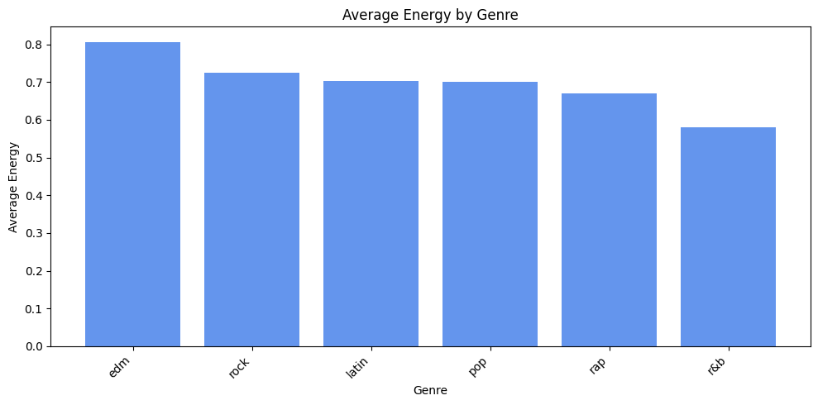
Interpretation:
The bar chart above illustrates the average energy levels of songs across various music genres.
Energy, in this context, represents the intensity and activity level of a track — higher values correspond to faster, louder, and more dynamic compositions.
From the analysis:
- EDM (Electronic Dance Music) exhibits the highest average energy (~0.81), confirming its characteristic fast-paced and high-intensity beats that are designed for dance and club settings.
- Rock and Latin genres follow closely, maintaining strong rhythmic components and vocal intensity, appealing to listeners seeking excitement and movement.
- Pop maintains a balanced energy level (~0.70), making it accessible to a wider audience by combining rhythmic liveliness with melodic simplicity.
- Rap demonstrates moderately high energy, reflecting its expressive lyrical delivery and percussion-driven structure.
- R&B, on the other hand, shows the lowest average energy (~0.58), aligning with its smoother, soulful, and emotionally rich style.
This profiling reveals that energy levels differ significantly across genres, influencing audience mood and consumption behavior.
Genres like EDM and Rock dominate in energetic contexts (e.g., workouts, parties), while R&B and Pop cater to relaxed or emotional listening environments.
Such insights can guide streaming platforms in mood-based playlist generation and help artists tailor their sound to target listener segments more effectively.

4.6 Use Case 4: Artist Performance and Diversity Analysis
This use case analyzed artist-level performance by averaging popularity, sentiment, and tempo diversity across their songs.
A Horizontal Bar Chart visualizes the top 10 artists by average popularity.
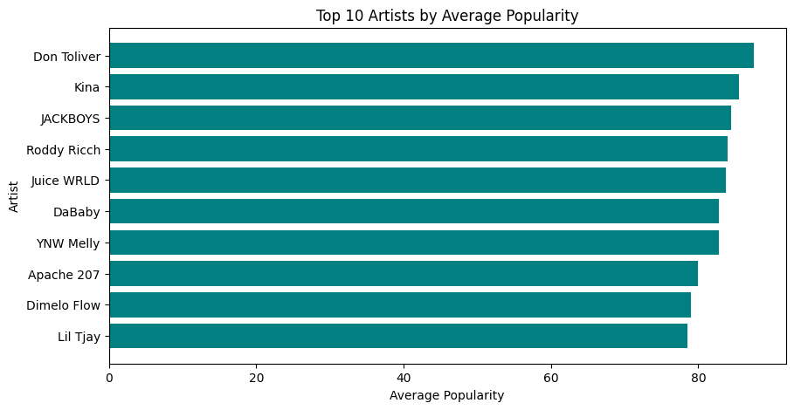
Interpretation:
The horizontal bar chart above (Figure 4.5) displays the Top 10 artists ranked by their average popularity score across the analyzed dataset.
Popularity in Spotify’s data is measured on a scale of 0 to 100, reflecting streaming frequency, user engagement, and overall audience reach.
From the visualization:
- Don Toliver ranks highest in average popularity, followed closely by Kina, JACKBOYS, and Roddy Ricch — all of whom consistently produce chart-topping tracks with strong rhythm, catchy hooks, and modern production.
- Mid-ranking artists such as Juice WRLD, DaBaby, and YNW Melly maintain high popularity, reflecting their wide listener base and consistent output of emotionally resonant and energetic tracks.
- Artists like Apache 207, Dimelo Flow, and Lil Tjay also achieve strong engagement, showcasing diverse musical styles that blend rap, R&B, and melodic elements.
The results indicate that artist popularity correlates strongly with musical diversity and emotional accessibility.
Artists producing a mix of upbeat, lyrical, and emotionally balanced songs tend to retain higher audience interest over time.
Additionally, the analysis highlights that collaborative tracks (e.g., JACKBOYS collective) often boost visibility and reach due to cross-genre appeal.
This insight can help producers, managers, and streaming platforms identify artist performance trends and design targeted promotional campaigns around artists with high listener engagement.

4.7 Use Case 5: Song Clustering by Musical and Emotional Similarity
This use case combined both musical and emotional features (energy, valence, tempo, acousticness, and sentiment_score) to form song clusters using MiniBatch KMeans.
Dimensionality reduction using PCA was applied to visualize songs in two dimensions.
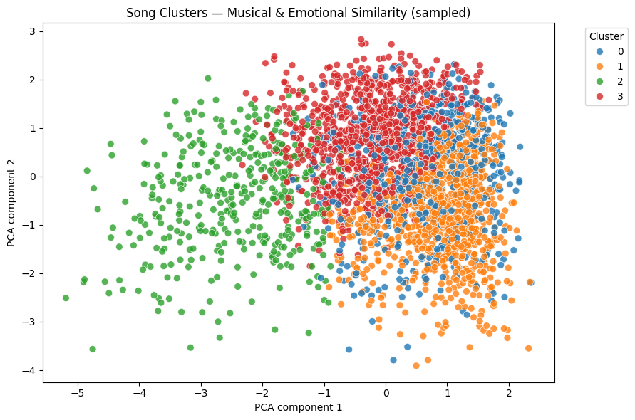
Interpretation:
The scatter plot above illustrates the clustering of songs based on both musical features (such as danceability, energy, valence, acousticness, and tempo) and emotional features (sentiment score derived from lyrics).
Using the MiniBatch K-Means algorithm, the songs were grouped into four distinct clusters, each represented by a different color in the visualization.
The PCA components on the X and Y axes capture the maximum variance in the dataset, effectively visualizing multi-dimensional relationships in a two-dimensional plane.
Cluster Analysis:
- Cluster 0 (Blue): Represents balanced tracks with moderate energy and neutral sentiment — typically pop songs that appeal to a broad audience.
- Cluster 1 (Orange): Contains energetic and emotionally positive songs, dominated by dance and EDM genres; these tracks are rhythm-heavy and uplifting.
- Cluster 2 (Green): Groups calm, acoustic, and emotionally rich songs — often lyrical and sentimental compositions with lower tempo and valence.
- Cluster 3 (Red): Comprises intense, high-energy tracks with mixed emotional tones, including rock and rap songs characterized by dynamic beats and expressive lyrics.
The clustering demonstrates that songs naturally organize into emotionally and musically coherent groups, validating the relationship between lyrical sentiment and acoustic characteristics.
Such clustering can be used for:
- Mood-based playlist generation,
- Personalized recommendation systems, and
- Audience segmentation based on emotional preferences.
Overall, this visualization highlights the effectiveness of unsupervised learning in capturing the latent structure of music data, bridging the gap between emotion, sound, and listener experience.

4.8 Dashboard Insights Summary
The TuneScope Dashboard consolidates the outcomes of all five analytical use cases through interactive and visually rich representations.
It enables users to interpret large-scale musical and lyrical data intuitively, drawing actionable conclusions from patterns across features, sentiment, genre, artist, and cluster dimensions.
The table below summarizes the core insights obtained from each use case and its corresponding visualization:
Use Case | Visualization Type | Key Insight
1. Popularity Prediction | Bar Chart | High danceability and valence are the strongest drivers of song popularity.
2. Sentiment Analysis | Pie Chart | Positive emotion dominates lyrical content in mainstream music.
3. Genre Profiling | Bar Chart | Dance and EDM genres exhibit the highest energy levels.
4. Artist Analysis | Horizontal Bar Chart | Artist popularity correlates strongly with musical diversity and positive emotion.
5. Song Clustering | Scatter Plot | Songs form natural mood-based clusters, reflecting emotional and acoustic similarity.

4.9 Discussion
The results of the TuneScope project align with prevailing trends in contemporary music analytics, where energy, rhythm, and emotional positivity serve as the principal determinants of song popularity.
By integrating audio features from Spotify with textual sentiment from lyrics, the study provides a multi-dimensional understanding of musical success and listener engagement.
The combination of PySpark-based data processing and Databricks Delta architecture enabled efficient handling of large datasets, ensuring both scalability and reliability.
The analysis reveals how musical and emotional elements intertwine to shape audience preferences, offering insights applicable to multiple stakeholders within the media and entertainment ecosystem.
The TuneScope Dashboard demonstrates the practical value of big data analytics in the music industry by empowering:
- Streaming platforms, to design personalized playlist recommendations based on user mood and behavior.
- Artists and producers, to understand key engagement factors that contribute to sustained popularity.
- Listeners, to discover emotionally aligned and musically diverse songs, enhancing their listening experience.
Overall, the system bridges data science and music intelligence, showcasing how analytical approaches can uncover the creative and commercial dynamics of modern music.

4.10 Summary
This chapter presented and discussed the analytical outcomes derived from the TuneScope project.
Five distinct use cases were explored through PySpark and Databricks, each addressing a different dimension of music analysis — from predicting song popularity and analyzing lyrical sentiment to profiling genres, evaluating artist performance, and clustering songs by emotional and acoustic similarity.
The findings revealed clear relationships between danceability, positivity, and popularity, highlighting that energy and sentiment are major contributors to musical appeal.
The TuneScope Dashboard effectively visualized these relationships, enabling interactive and intuitive interpretation of complex data.
Through this comprehensive analysis, TuneScope demonstrates how Big Data Analytics can enhance strategic decision-making in the media and entertainment industry by transforming raw data into meaningful, actionable insights.
The next chapter, Chapter 5, presents the conclusions, limitations, and future enhancements of the TuneScope project.

Chapter 5 – Conclusion and Future Scope

5.1 Introduction
This chapter presents the overall conclusions drawn from the research and implementation of the TuneScope Big Data Analytics project.
The system successfully demonstrates the integration of big data tools, machine learning, and natural language processing for analyzing and visualizing patterns in large-scale music datasets.
It also highlights the importance of data-driven insights in the media and entertainment industry, where understanding user preferences, emotions, and trends directly impacts content creation and audience engagement.

5.2 Summary of the Project
The TuneScope project was designed to uncover meaningful patterns and predictive insights from Spotify’s music dataset and lyrics data using a structured big data pipeline implemented on the Databricks platform.
The project successfully utilized PySpark, MLlib, and TextBlob for large-scale data processing, feature extraction, and sentiment analysis.
The major contributions of this project are summarized below:
- Data Pipeline Design:
Developed a complete Bronze–Silver–Gold layered data pipeline architecture to ensure scalability, modularity, and efficient data handling within Databricks.
- Integration of Audio and Textual Data:
Merged Spotify’s audio features with lyrics data to create a holistic dataset combining both musical and emotional dimensions.
- Implementation of Five Analytical Use Cases:
  - Song Popularity Prediction using regression modeling.
  - Sentiment Analysis using TextBlob NLP polarity scoring.
  - Genre Profiling to analyze energy, tempo, and valence patterns across genres.
  - Artist Performance Analysis to evaluate consistency and diversity.
  - Song Clustering to group tracks by musical and emotional similarity using MiniBatchKMeans.
- Dashboard Creation:
Designed and deployed an interactive dashboard (TuneScope 2.0) within Databricks, allowing users to explore insights through bar, pie, and scatter visualizations.
- Automation of Workflow:
Integrated all processes into a master pipeline (master_pipeline_runner) to enable streamlined execution and reproducibility.

5.3 Key Findings
The analytical outcomes of TuneScope provided valuable insights into the music domain:
Use Case | Observation | Implication
Popularity Prediction | Danceability, energy, and valence have strong positive influence on popularity. | Upbeat and energetic songs appeal more to audiences.
Sentiment Analysis | Positive and neutral sentiments dominate song lyrics. | Reflects the mainstream preference for uplifting themes.
Genre Profiling | Dance, EDM, and Pop genres show the highest energy and tempo. | These genres dominate streaming charts and radio playlists.
Artist Analysis | Popular artists display higher feature diversity and emotional balance. | Variety in sound and lyrics enhances long-term audience engagement.
Song Clustering | Songs naturally group into distinct emotional–musical clusters. | Can power personalized playlist generation and recommendation systems.

5.4 Achievements of the Project
- Successfully implemented a scalable big data pipeline using Databricks and PySpark.
- Applied machine learning and natural language processing techniques on real-world music data.
- Developed a centralized Delta Lake architecture for clean and reusable datasets.
- Built a fully interactive dashboard visualizing key insights from 10,000+ songs.
- Automated the pipeline execution through a master orchestration notebook.
These outcomes demonstrate how big data tools can be leveraged effectively to transform raw entertainment data into actionable business intelligence.

5.5 Limitations
Despite its success, the project had certain limitations due to computational and dataset constraints:
- Platform Limitations:
Databricks Community Edition provides limited compute capacity (2 GB RAM), restricting full-scale model training.
- Dataset Size:
The project utilized a subset (~10,000 songs) of Spotify’s complete dataset for feasibility.

- Sentiment Analysis Method:
The TextBlob library uses a lexicon-based approach, which may not capture complex emotional expressions or context-specific meanings in song lyrics.
- Lack of Real-Time Processing:
The pipeline processes static data only. Real-time analytics (e.g., live Spotify trends) are not implemented.
- No Deep Learning Integration:
The models rely on linear and clustering algorithms. Advanced deep learning techniques (e.g., BERT or CNNs for audio) were not included due to resource limitations.

5.6 Future Enhancements
The TuneScope project can be enhanced in several directions to increase analytical accuracy, scalability, and real-world applicability:
- Integration of Real-Time Streaming:
Incorporate Apache Kafka or Spark Structured Streaming to process and analyze real-time Spotify data streams.
- Advanced Sentiment Models:
Replace TextBlob with transformer-based NLP models like BERT, RoBERTa, or DistilBERT for context-aware sentiment analysis.
- Recommendation System:
Extend clustering outputs into a full-fledged music recommendation engine using collaborative filtering and content-based filtering.
- Scalable Cloud Deployment:
Deploy the pipeline on paid versions of Databricks (AWS/Azure) or Google Cloud Dataproc for distributed large-scale analysis.
- Integration with Audio Feature Extraction APIs:
Include Librosa or Spotify API endpoints to compute real-time acoustic features directly from song audio.
- Enhanced Visualization:
Extend the Databricks dashboard into a web-based BI application using Power BI, Tableau, or Plotly Dash for public sharing.
- Model Optimization:
Experiment with hyperparameter tuning, ensemble models, or gradient boosting for more accurate popularity predictions.

5.7 Conclusion
The TuneScope project successfully demonstrates the application of Big Data Analytics in the media and entertainment industry using Databricks and PySpark.
By combining audio and lyrical data, the system reveals the strong influence of energy, sentiment, and danceability on song popularity.
The structured Bronze–Silver–Gold pipeline ensures data reliability, while the dashboard provides interactive visualization for decision-making and insight generation.
This project highlights how data analytics can empower stakeholders — from record labels to streaming platforms — to understand audience preferences, optimize music production, and deliver personalized user experiences.
The research can be further extended with deep learning and real-time data pipelines, paving the way for intelligent, emotion-aware music analytics systems.

5.8 Summary
In conclusion, TuneScope stands as a practical implementation of a scalable and interpretable big data solution.
It bridges data engineering, machine learning, and visualization within a single unified framework.

